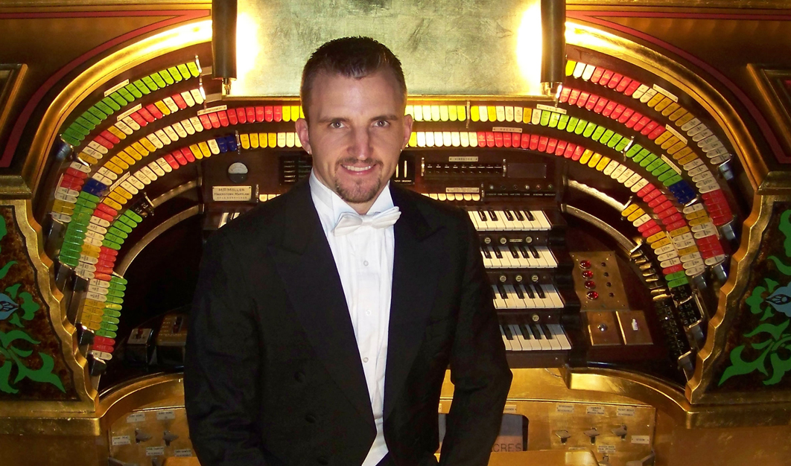

Steven Ball is an organist, carillonneur, improviser, composer, conductor, campanologist, organ consultant and specialist in silent film accompaniment.
A native of Michigan originally, Dr. Ball studied at the University of Michigan and received his DMA in 2007 as a student of Marilyn Mason. He later went on to serve as University Carillonneur and teach as a faculty member of the Organ Department and has since served in several prominent churches and public institutions across the country over the years including as Organist and Director of Outreach (now Emeritus) for the world's largest pipe organ in Atlantic City, as well as the Cathedrals of Detroit and Philadelphia. He is currently Artist in Residence at the Tampa Theatre in Tampa FL and maintains an active schedule traveling extensively as a consultant and concert artist.
He has been responsible for several unique accomplishments and collaborations professionally, including the centralization of the Organ Historical Society (OHS) and their archives to a new facility at Stoneleigh in Villanova, PA. In addition, he has served as co-chair for the 2016 OHS convention in Philadelphia, Dean of the South-Jersey Chapter of the American Guild of Organists (AGO) from 2016-2018 and is currently serving on the Board of Directors for the St. Louis Chapter of the AGO in addition to being chair of the Program Committee for the upcoming National 2026 AGO convention in that city. World premiere performances have included works for organ and orchestra as well as carillon.
A former Fulbright Scholar to the Netherlands, he has traveled and performed extensively in both the United States and abroad including concerts in the Netherlands, Germany, Belgium, France, Portugal, Ireland, England, Switzerland and Italy.

